**All sections are mandatory. All details in Section 1 must be provided and match the online form of CIFCA 2025 to be published.**

**Section 1: Entrant’s Details**

|  |  |
| --- | --- |
| **Category Name:** |  |
| **Credited Campaign Title:**  *(Should not exceed 8-word counts)* |  |
| **Credited Brand Name:** |  |
| **Credited Market:** |  |

**Each section header must be included as exactly as listed below. Failing to comply might result in marks being deducted by the judge.**

**The description is optional to include if more space is required.**

|  |  |  |  |  |
| --- | --- | --- | --- | --- |
| **Section 2:** | **Film Objectives and Challenges** | | | 10% |
| * **Provide a brief synopsis** of the film, including its genre, target audience, and the creative vision behind it. * **Describe the objectives** of the film, such as brand communication, audience engagement, or storytelling goals. * **Highlight any unique challenges** faced during the production process and how they were addressed. | | | | |
| **Section 3:** | **Creative Strategy** | | | 20% |
| * **Outline the creative strategy** behind the film, including the concept, narrative structure, and visual style. * **Highlight any innovative techniques** used in cinematography, editing, sound design, or visual effects. * **Explain how the film aligns** with the brand's messaging and objectives (if applicable). | | | | |
| **Section 4:** | **Creativity & Innovation** | | | 25% |
| * Describe any creative idea or innovative concept including any creative selection of communications channels, and innovation in the measurement of the results. | | | | |
| **Section 5:** | **Execution** | | | 20% |
| * **Describe the execution process**, including pre-production, production, and post-production stages. * **Describe any creative and tactics** linking executional elements back to the strategy. | | | | |
| **Section 6:** | | **Results** | 25% | |
| * **Provide quantitative and qualitative results** to demonstrate the film's effectiveness, including key metrics such as audience reach, engagement, and brand impact. * **Describe how the film met or exceeded its objectives**, and how it contributed to the brand's overall goals (if applicable). * **Include any measurable outcomes**, such as awards, recognition, or significant improvements in brand perception. | | | | |

**Important point to be noted   
  
Payment and Submission** *(Mandatory)*

* Ensure all entry fees are paid by the specified deadlines (Early Bird, Standard, or Final).
* Submit the entry online via the CIFCA 2025 entry platform, ensuring all sections are completed and all required materials are uploaded.

## **Judging Criteria**

* **Execution Excellence (30%)** – Judges will assess the technical and creative execution of the film, including production quality, visual impact, and storytelling.
* **Innovation (25%)** – Judges will look for unique and creative approaches that set the film apart from conventional methods.
* **Impact and Effectiveness (25%)** – Judges will evaluate the film's ability to achieve its objectives and deliver measurable results.
* **Relevance to Category (20%)** – Judges will consider how well the film aligns with the specific category it is entered in.

## **Terms and Conditions**

* **All entries must comply** with the eligibility period **(1 March 2024 to 28 February 2025).**
* **Entries must be original** and owned by the entrant, with all necessary permissions secured.
* **Any changes to the entry** after submission will incur a fee and must be approved by the organizer.
* **The judges' decisions are final**, and no correspondence will be entered into regarding the results.

**HOW TO CREATE ENTRY?**

1. Click [**ENTER NOW**](https://www.ciawards.in/register) via awards website to register as a user. Email verification will be sent to the registered person. Do not use the previous year's login credentials.
2. Fill in pre-requisite details including Primary and Secondary contacts. (Primary contact will be KEY point of contact for award related communication.)
3. Log on using the credentials as per registered. Create your entry and complete the Online form (all sections are mandatory).
4. Upload your submission and required materials. Save as draft to edit later. Ensure all credits and file specifications are correct. Preview before final submission- no changes allowed after confirmation.

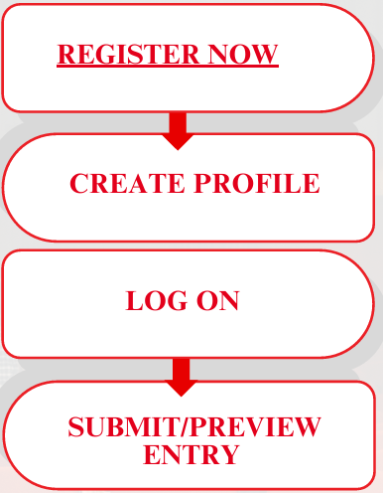

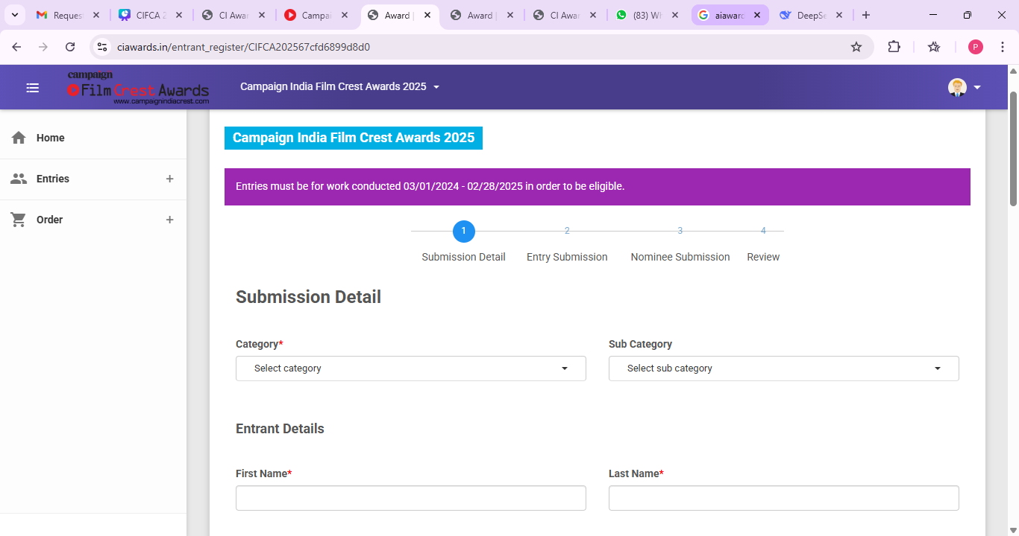

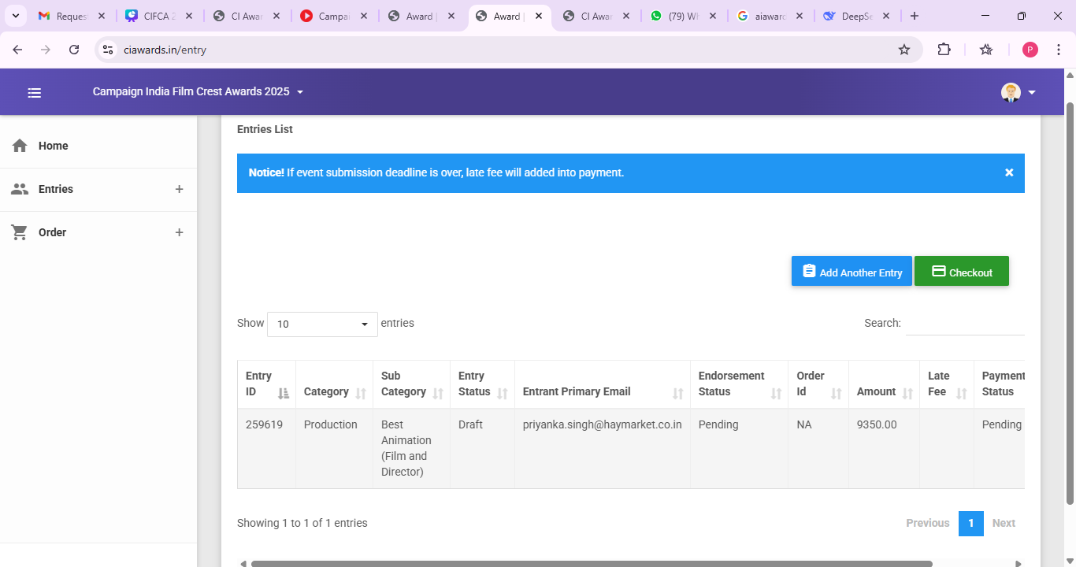Log on using the credentials as per registered, create your entry and complete the Online form (all sections are mandatory).

**Create a new entry** or **proceed to payment**. Entry is complete once an ORDER ID is generated and email confirmation is received.

**HOW TO CONFIRM ENTERY?**

